EART11300 | Volcanism in the Earth system | Hazards, Vulnerability and Risk
Today we will explore three critical concepts in volcanology: hazards, vulnerability, and risk. Last week we learned that volcanic eruptions, generally speaking, can be either explosive or effusive.
Explosive eruptions occur when magmas have high volatile content (lots of bubbles) and high viscosity (thick, not runny). Since the bubbles cannot rise or expand freely, pressure builds inside them. Eventually the bubbles burst, tearing apart the magma in a process called fragmentation. Explosive eruptions are associated with high-silica magmas in subduction zones (volcanic arcs) and their products therefore involve ash, volcanic bombs and other particulate debris, as well as pyroclastic density currents. Ash on steep volcanic slopes can later be remobilised by water (e.g. rainwater, snow/ice melt) to form mudflows called lahars.
Effusive eruptions occur when magma does not undergo fragmentation, due to a lower volatile content or because bubbles can rise freely through the low viscosity basaltic magma. The magma reaches the surface as a liquid and flows out over the surface as a lava flow. These eruptions can also involve lava fountaining and the construction of small cones. This style of volcanism is typically found in ocean islands (hotspots).
The different eruptive behaviours of volcanoes (lava flows, ashfall, pyroclastic density currents, lahars etc) are all hazards (Figure 1). This is because they can potentially cause harm to people’s lives, to their livelihoods, to infrastructure like buildings or roads, or to arable land and water supplies. The potential impact of a hazard is called the risk. Consider how many fatalities may occur in an eruption, or how much money would need to be spent to fix the damage caused by an eruption. Higher risk events are those which could cause more deaths or which would cost more to mitigate.
Calculating risk is very complex, partly because volcanic hazards vary between different volcanoes and eruptions. Also, risk depends on vulnerability. This is a measure of the valuable ‘assets’ (people, livestock, land, infrastructure, etc) in the path of a hazard. High vulnerability might result from:
- a large population around a volcano,
- the fact that a volcano is on a small island which would be hard to evacuate,
- limited scientific (or public) understanding of a volcano and its hazards,
- very frequent eruptions or long delays (thousands of years) between eruptions,
- little trust between communities near a volcano and governmental decision makers.
If vulnerability factors can be identified, potentially work can be undertaken to reduce vulnerability – sometimes called strengthening resilience. Enormous amounts of research have been conducted (and continue) in what we call disaster risk reduction, for volcanoes, but also for large earthquakes, for floods, landslides, wild fires, and the impacts of climate change. This is a really important topic for all of humanity and many of you may go on to work in this critical area after your degrees.
Last week we studied images of eruptions and hand specimens of their products. This week we are going to study volcanic eruptive products on a larger scale, using Google Earth satellite imagery, and to place these in the context of their local to regional surroundings.
By the end of the class, you should be able to:
- Describe some of the key hazards associated with different kinds of volcanic eruption;
- Identify field evidence for these hazards using satellite imagery of active volcanoes;
- Assess vulnerability of populations and infrastructure in the regions surrounding active volcanoes;
- Understand that volcanic risks result from the combination of eruptive hazards and societal or environmental vulnerability.
- Suggest ways to reduce or mitigate volcanic risk in different settings around the world.
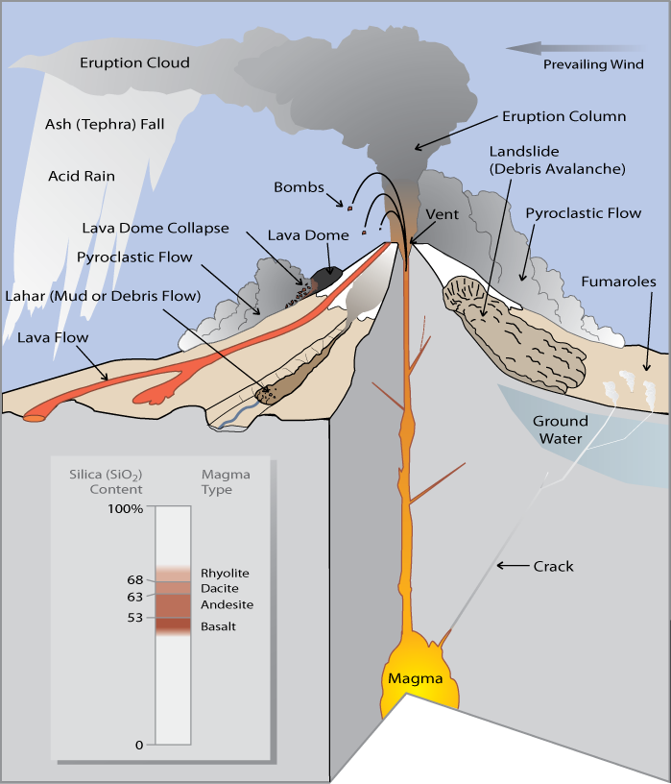
Figure 1. Some examples of different hazards associated with volcanic eruptions. You can also think back to some of the images we saw last week (for a reminder, see the Appendix to this handout!). If you do not know what some of these hazards are, ask a demonstrator before continuing.
Part 1: Volcanic hazards
We are going to compare and contrast the volcanic hazards associated with explosive and effusive styles of volcanism. Our example of explosive volcanism is the stratovolcano Mt St Helens in the Cascades Volcanic Arc. Our example of effusive volcanism are the shield volcanoes of Mauna Kea, Mauna Loa and Kilauea on the Big Island of Hawaii.
Click this link to navigate to Google Earth. It should open in a web browser and you should see a list of volcanic regions that I have bookmarked for you. Visit both Hawaii and Mt St Helens and explore the landscapes. To fly around the landscape, you can use the arrow keys on your keyboard while holding down “Shift” or “Ctrl”. If you are using a touch screen you can experiment with pinching and sliding motions – ask a demonstrator for help if you need to.

Mt St Helens
Mt St Helens erupted violently in May 1980 after a long period of restless behaviour (earthquakes, ground deformation, gas and thermal emissions, small ash venting explosions). 57 people were killed in this complex eruption which involved a number of important elements (Figure 2):
- A shallow intrusion of magma (‘cryptodome’) into the volcanic edifice caused a bulging of the mountain, making it highly unstable.
- A magnitude 5.2 tectonic earthquake shook the Cascades region and caused a major landslide to occur in Mt St Helens’ flank.
- The rapid removal of a huge mass of rock exposed and decompressed the fresh magma of the cryptodome, causing a violent and explosive expansion of volatiles, causing the magma to undergo explosive fragmentation.
- A powerful vertical explosive eruption began, accompanied by a ‘lateral blast’, where pyroclastic material was ejected horizontally from the volcano as a result of the flank collapse.
- The lateral blast caused an enormous high temperature shockwave to travel northwards across the landscape, destroying all in its path.
- This was followed by waves of pyroclastic density currents from the lateral blast as well as collapses of the vertical eruption column. The entire region was blanketed in ash.
- Melting of the summit glacier generated lahars which swept down the river valleys around the volcano. Further lahars followed from the unstable and rapidly deposited pyroclastic deposits.
- Once the explosive activity halted, a new lava dome began to grow in the large crater formed by the explosive eruption and lateral blast.
Using Figure 3 as a guide, look for evidence of (1) ashfall, (2) pyroclastic flows, (3) the debris avalanche caused by the landslide, (4) damage caused by the shockwave, and (5) lahars. I have placed purple flags in the landscape to guide you. Click on one to view prompts/questions. Make notes describing what you see.

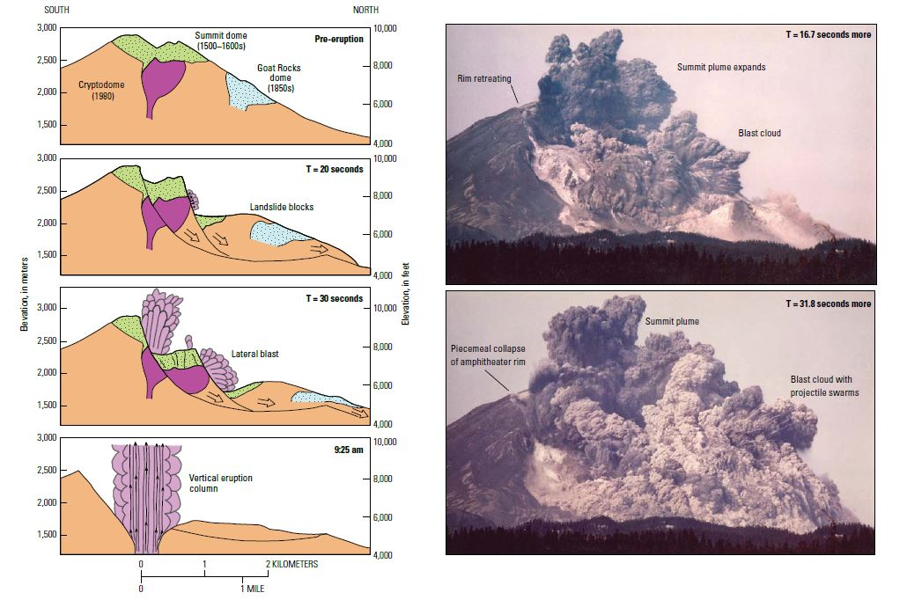
Figure 2. Sketches showing the processes which occurred during the onset of the May 1980 Mt St Helens eruption, along with two photographs within the first minute of the eruption. Credit USGS and Gary Rosenquist.
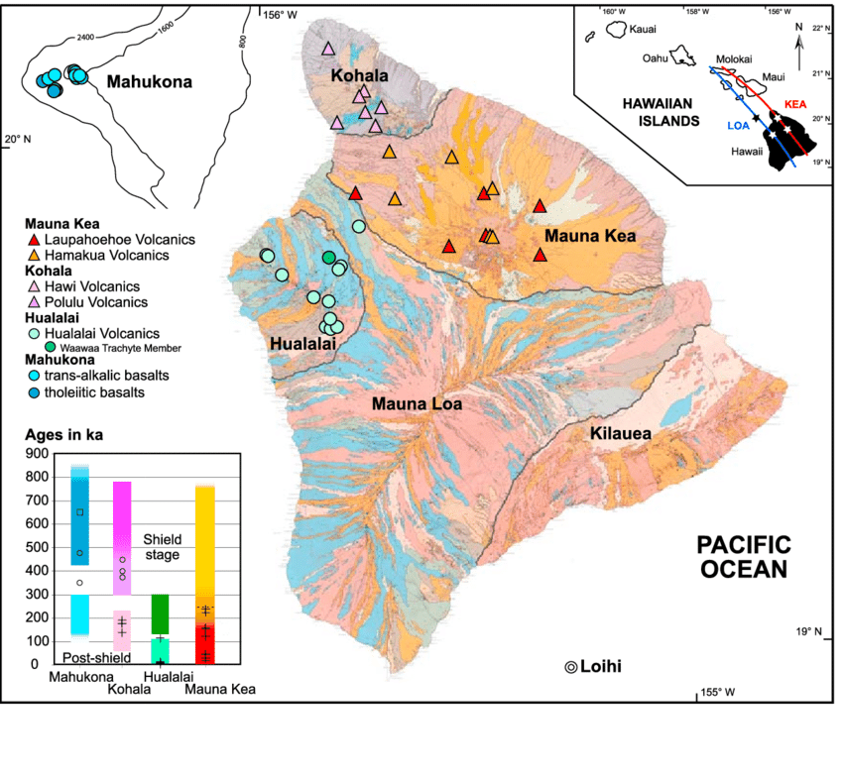
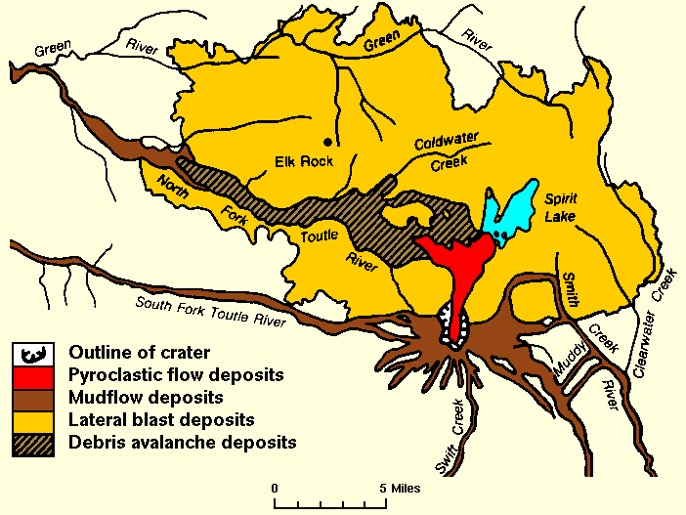
Figure 3. Summary of volcanic deposits around Mt St Helens, courtesy US Geological Survey.
Figure 4. Geological map of the Big Island of Hawaii, showing the five main shield volcanoes.
Hawaii
The Big Island of Hawaii is home to a number of shield volcanoes (Figure 4) and today we will study Mauna Kea, Mauna Loa and Kilauea. At any given time, one of these is the site of most current volcanism, and we can infer the relative ages of the volcanoes from the level of re-vegetation. Mauna Kea is the oldest of the volcanoes we will study, having started its activity around 1 million years ago and now being considered inactive. Mauna Kea has passed into a ‘post-shield’ stage, involving somewhat more volatile-rich and higher viscosity magma, and you will see the impact of this change on the volcanic landforms.
Mauna Loa and Kilauea are classic examples of shield volcanoes, with shallow slopes like an upturned bowl. They are mostly constructed of overlapping lava flows, though the distribution of these flows and the fissures and vents they originate from, varies through time. Largely, eruptive vents and fissures are controlled by a tectonic influence, specifically the extensional influence of the slow collapse of the shields. Both volcanoes have striking ‘rift zones’, lines marked as the origin point of numerous eruptions. In plumbing system terms, these lines mark the point that rising planes of magma (‘dykes’) intersect the surface.
One major hazard of this kind of volcanism that we cannot see with Google Earth is gas emissions. Although ocean island magmas tend to be less volatile rich than those we find in subduction zone settings, eruptions at ocean islands may have a much longer durations. This means that the cumulative emission of gas can be much higher and there can be longer intervals where emissions are affecting the surrounding area. You should bear this in mind in the following section when we consider vulnerability and risk.
As before, navigate to Google Earth and explore the landscape of the Big Island, bearing in mind to contrast it with Mt St Helens. This time there are yellow flags to guide you to features of interest.

Other examples
Here are some other examples of ocean island volcanoes (basaltic, effusive, shield volcanoes, fissure eruptions, lava flows, potentially cone building) and arc volcanoes (basaltic, andesitic, dacitic, more explosive, stratovolcanoes, involving ashfall, pyroclastic density currents, potentially lava domes). I encourage you to have a look at these volcanoes in Google Earth, and try to find similar landscapes to those you have seen already at Hawaii and Mt St Helens.
Ocean island volcanoes:
- Pico do Fogo, Cape Verde Islands
- Fagradalsfjall, Iceland
- Tristan da Cunha, South Atlantic
- Piton de la Fournaise, La Reunion
- Volcan Wolf, Galapagos
Arc volcanoes:
- Sinabung and Merapi, Indonesia
- Soufriere Hills, Montserrat
- Mayon, Philippines
- Fuego, Guatemala
- Lascar, Chile
- Vesuvius and Campi Flegrei, Italy
Part 2: Vulnerability to volcanic hazards
Vulnerability describes the exposure of valuable assets to natural hazards, such as volcanic eruptions. These assets may be populations, livestock, farmland, water supplies, infrastructure, and so on. If an eruption were to occur in some location, what would be lost or damaged by the eruptive products? What would be buried by lava flows in an ocean island setting, or covered by ashfall or pyroclastic flows in a volcanic arc setting?
Choose two volcanoes you have studied in the previous section. For each, study the surroundings in Google Earth and try to identify vulnerability to volcanic hazards. If your volcano has eruptions with a range of hazards, think about whether the vulnerability is different for each of these hazards (e.g. lahars vs pyroclastic density currents).
Some things to look for / consider:
- urban settings (small villages, large cities?)
- key infrastructure (airports, sea ports and harbours, single major roads, hospitals or power plants)
- land use in general: are volcanic slopes built on, cultivated, inhabited, etc?
- is the location isolated from or well-connected to the wider region?
- other environmental factors: glaciers to melt? Numerous volcanoes nearby? Topography that could funnel flow deposits?

These are all physical factors. There are also social factors to vulnerability. These are harder to assess using satellite imagery in isolation. We need to know information about the people living in the area affected by the hazard. Some things to consider:
- Wealth and poverty among the population
- Levels of awareness of volcanic hazard (/memory of last events, or general education)
- Corruption among governments, agencies, policy makers
- How effective communication is between government, scientists, media, the public
- Reliance on land (e.g. subsistence farming) vs reliance on imports (disrupted trade)
- Social issues in the wider region, e.g. conflict, displaced populations
- Healthcare: access to food, clean water, prevalence of diseases
For your two case study volcanoes, list potentially important social factors you should consider in this setting in order to make a full assessment of vulnerability.
Ask demonstrators if you need some guidance.

Part 3: Risk and risk reduction
Finally, we are going to consider the risk. Choose one of your volcanoes, and determine the risk (“high” or “low”) related to one of the eruption scenarios you have described, incorporating an understanding of vulnerability.
Often, we simply the assessment of risk to a basic equation, where risk = hazard x vulnerability. This shows us that the impact of any hazard can be amplified by high vulnerability. Equally, if we can reduce vulnerability then the risk associated with some hazard can be minimised.
To conclude, consider how risk could be minimised in the volcanic region you have studied. Think about possible solutions to reduce risk, from studying volcanoes to understand their hazards, to improving communications in remote areas, to raising levels of education in populations, or reducing vulnerability by decreasing societal inequalities. There are dozens of potential strategies and our main challenge is working out tailored solutions for complex individual cases. One really critical path to success I would like to emphasis is dialogue between at-risk communities and agencies working to help them, whether international scientific workers or local/national government. Communities often have particular issues or knowledge that is important to integrate into risk reduction strategies.
We cannot remove the risk from volcanoes by reducing hazards, as the volcanoes will certainly erupt again in future. However, decreasing vulnerability is feasible in many cases and is therefore a key part of disaster risk reduction.

Further reading
Barclay, J, et al. (2015). Social processes and volcanic risk reduction, from: Encyclopedia of Volcanoes, 2nd Edition, p1203-1214. https://www.sciencedirect.com/science/article/pii/B9780123859389000699
Appendix – images from last week
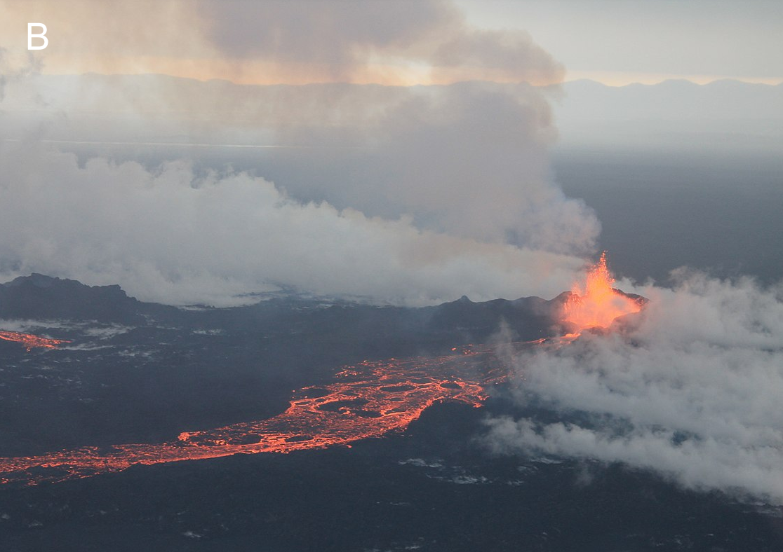
Fissure eruption with lava fountaining, Holuhraun, Iceland.

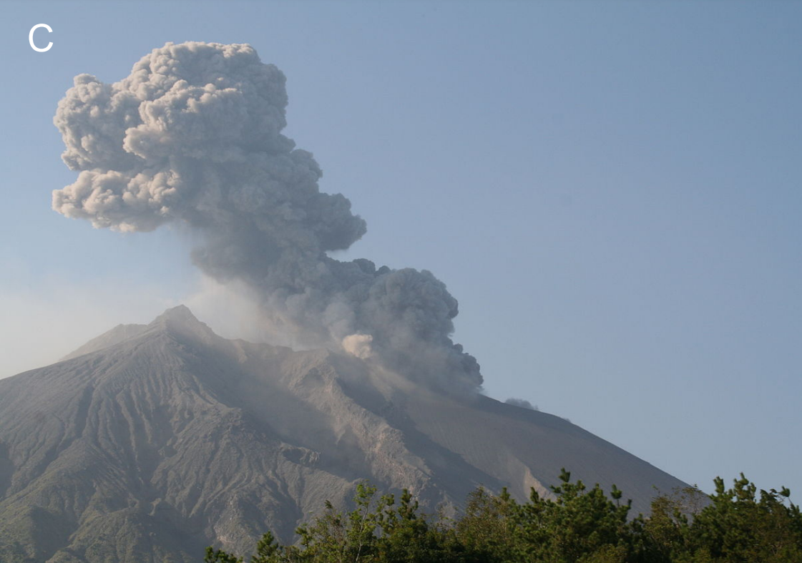
Vulcanian explosion (volcanic bombs) and ash column, Sakurajima, Japan.

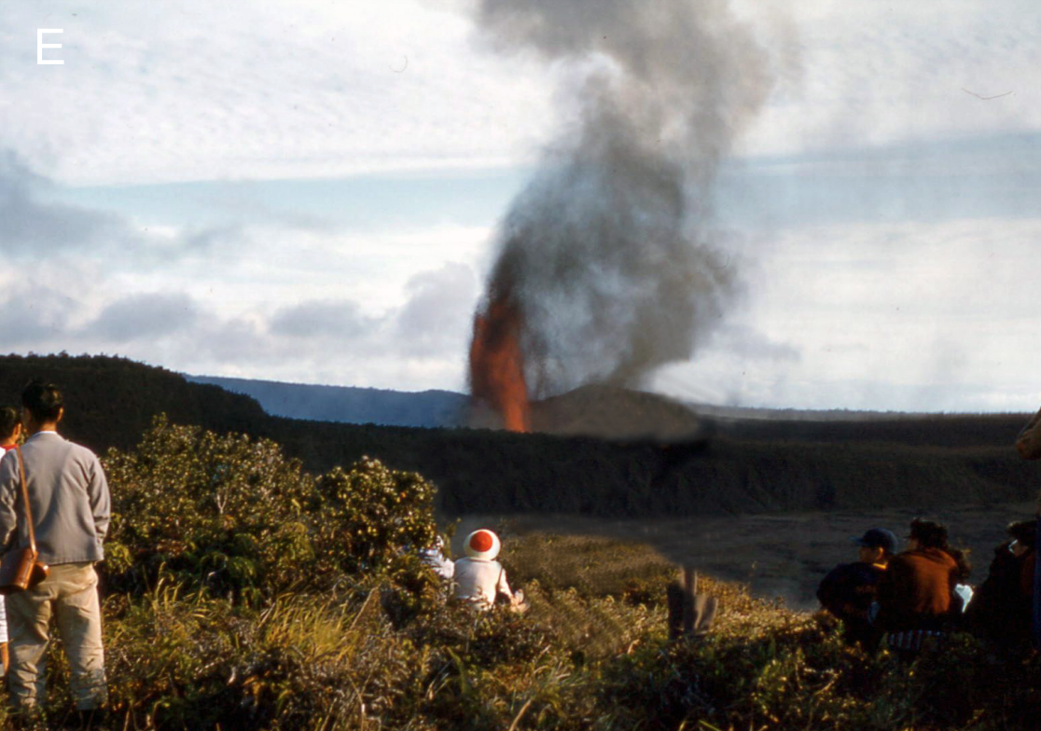
Hawaiian eruption, with lava fountain and some minor ash emissions, Kilauea Iki, Hawaii.

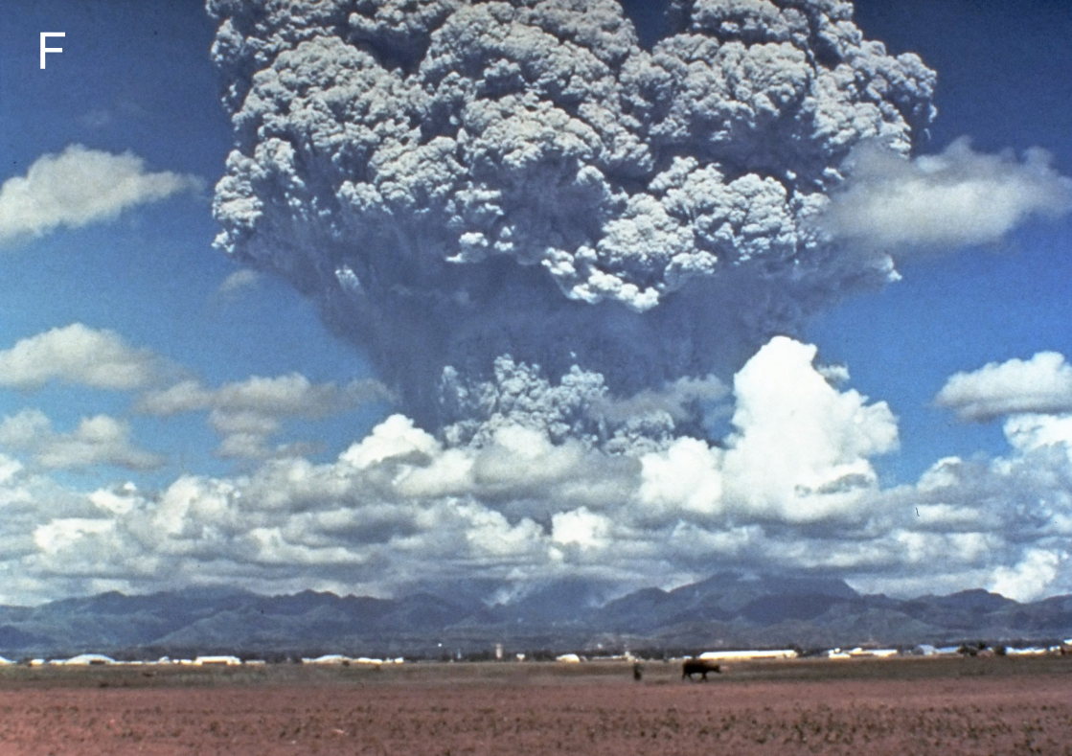
Plinian eruption, with very high vertical column with cauliflower structure, Pinatubo, Philippines.

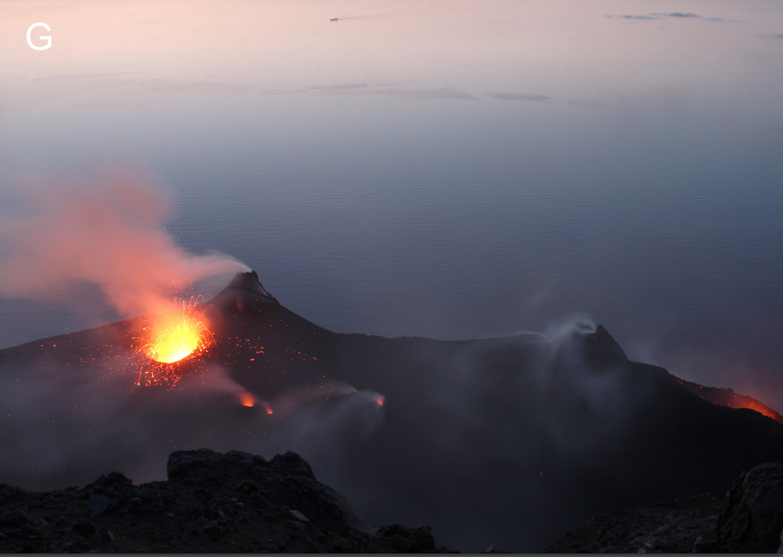
Strombolian activity, with incandescent ballistics thrown from small vents, Stromboli, Italy.

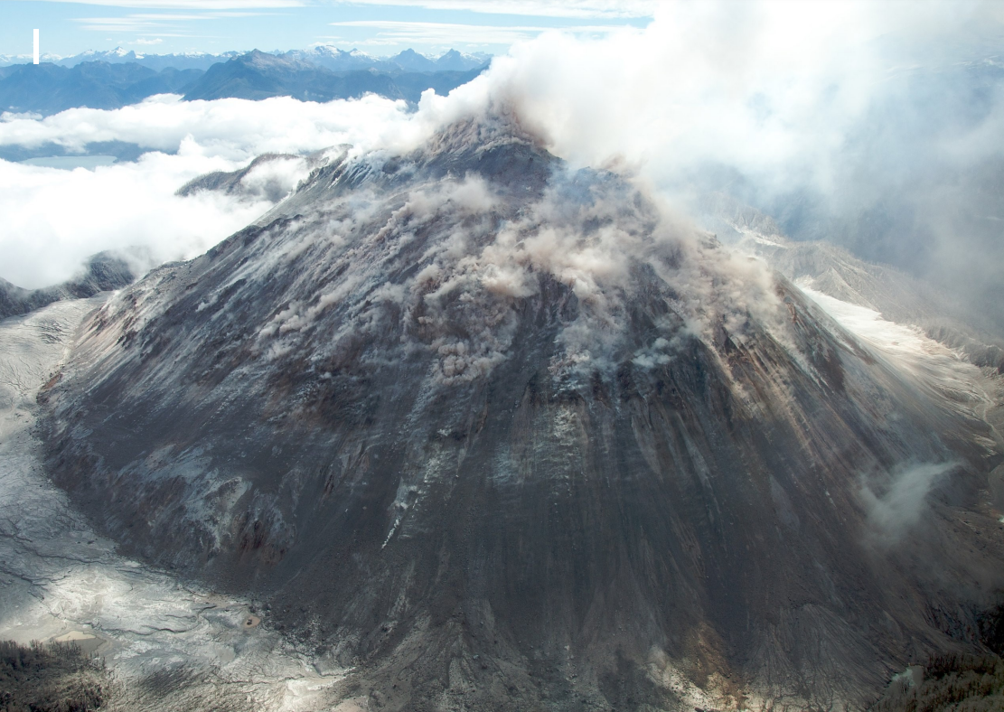
Lava dome, extruded from vent to fill summit crater, Chaiten, Chile.

